前提：数据已按要求格式整理好。

Basic:

1. Understand the problem:
   1. Classification: Show value count of categorical value.

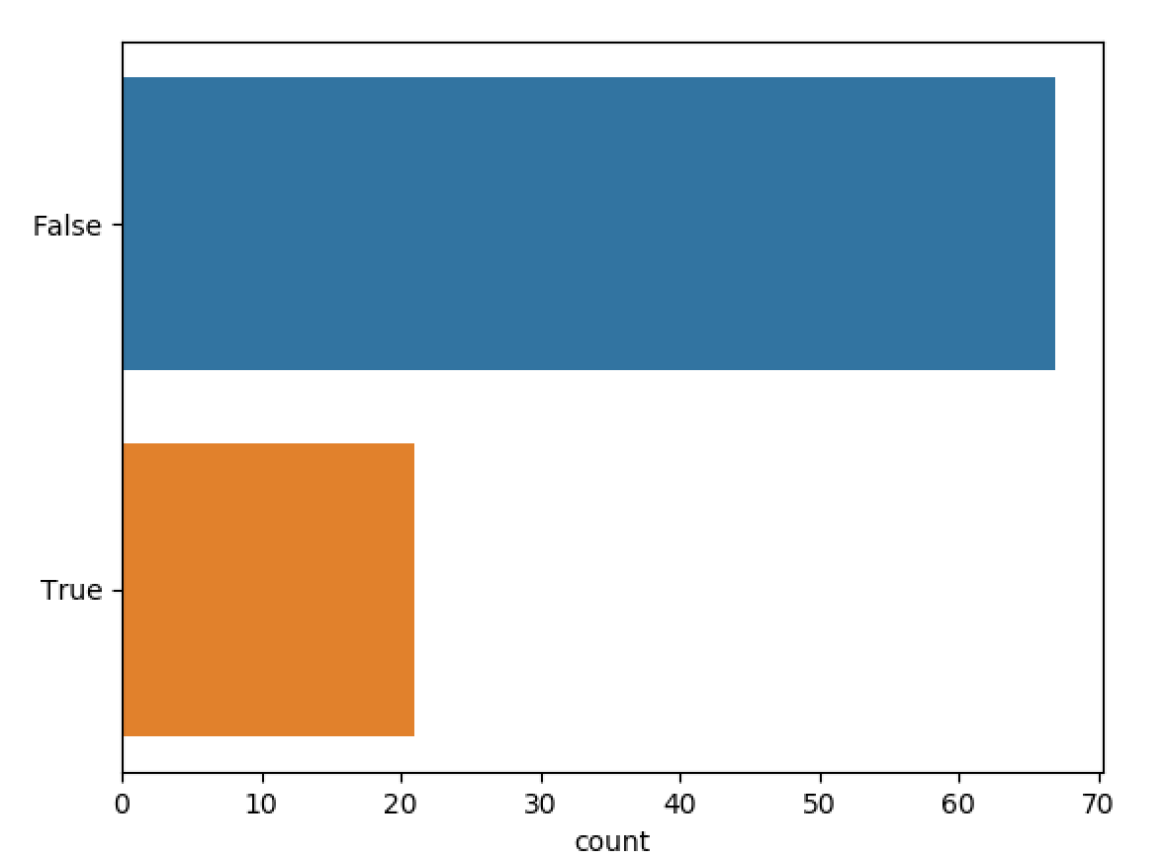

* 1. Regression:
     1. descriptive statistics summary

|  |
| --- |
| count 1320.000000  mean -2.345455  std 50.367960  min -260.000000  25% -4.000000  50% -1.000000  75% 3.000000  max 342.000000  Name: F_z, dtype: float64 |

* + 1. Histogram (value, percentile)

TODO1: 加一些常见分布的特性介绍，便于理解。

TODO2: 分析当前直方图可用何种分布拟合，置信度。

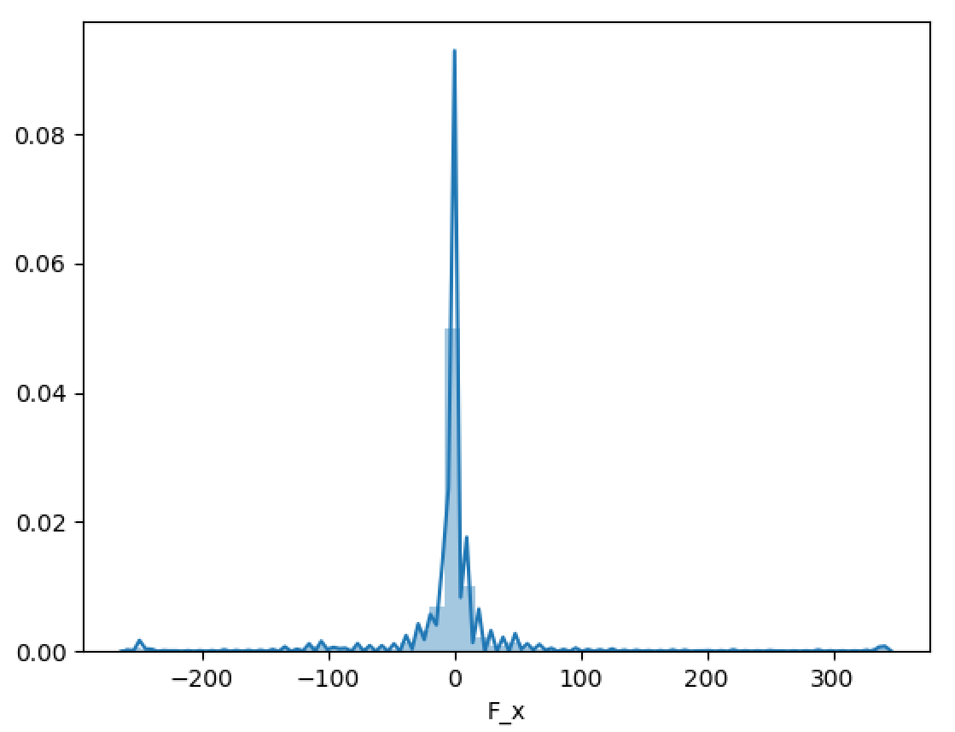

* + 1. Skewness and Kurtosis

|  |
| --- |
| Skewness: 1.065431  Skewness is a measure of the asymmetry of the probability distribution of a real-valued random variable about its mean.  Kurtosis: 23.187247  Kurtosis is a measure of whether the data are heavy-tailed or light-tailed relative to a normal distribution. That is, data sets with high kurtosis tend to have heavy tails, or outliers. Data sets with low kurtosis tend to have light tails, or lack of outliers. A uniform distribution would be the extreme case. |

TODO: 进一步解释Skewness和Kurtosis。

1. Series Basic （怎么选取series作此步分析暂时未定，可考虑随机选取，或按照feature importance选取有代表性地向用户展示）
   1. descriptive statistics summary (Count, Mean, STD, MIN, 25%, 50%, 75%, MAX)

方法同上，不赘述。

* 1. Line chart (time, value)

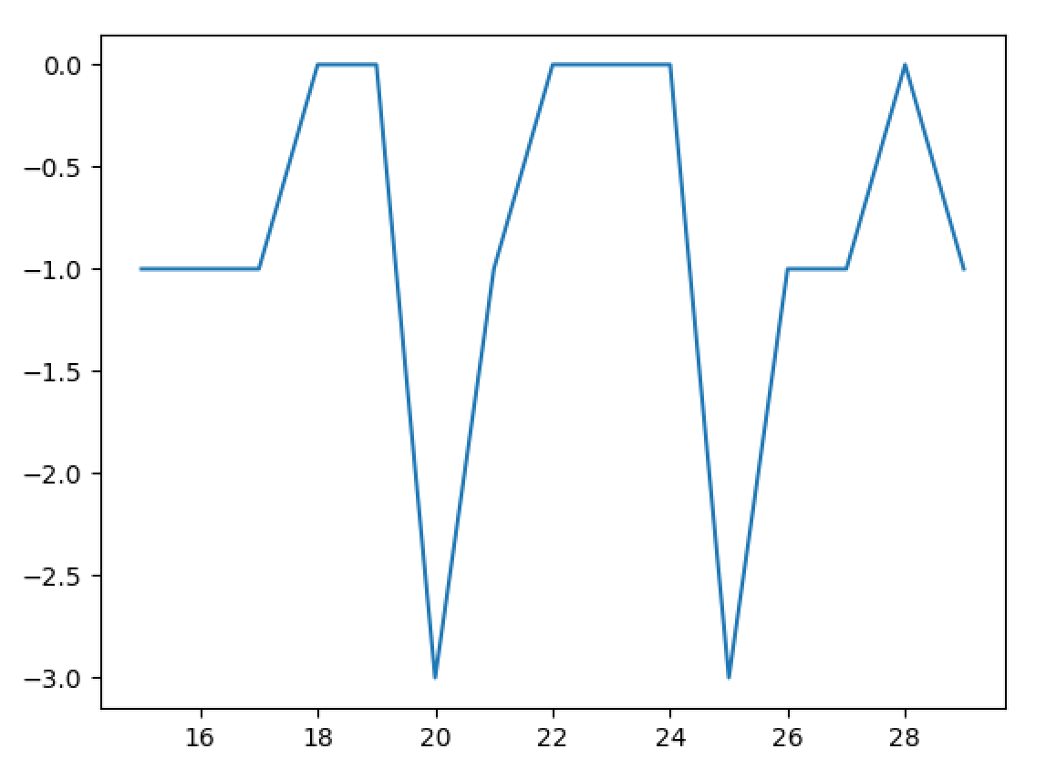

* 1. Skewness and Kurtosis

方法同上，不赘述。

* 1. Rolling Statistics: mean, std.

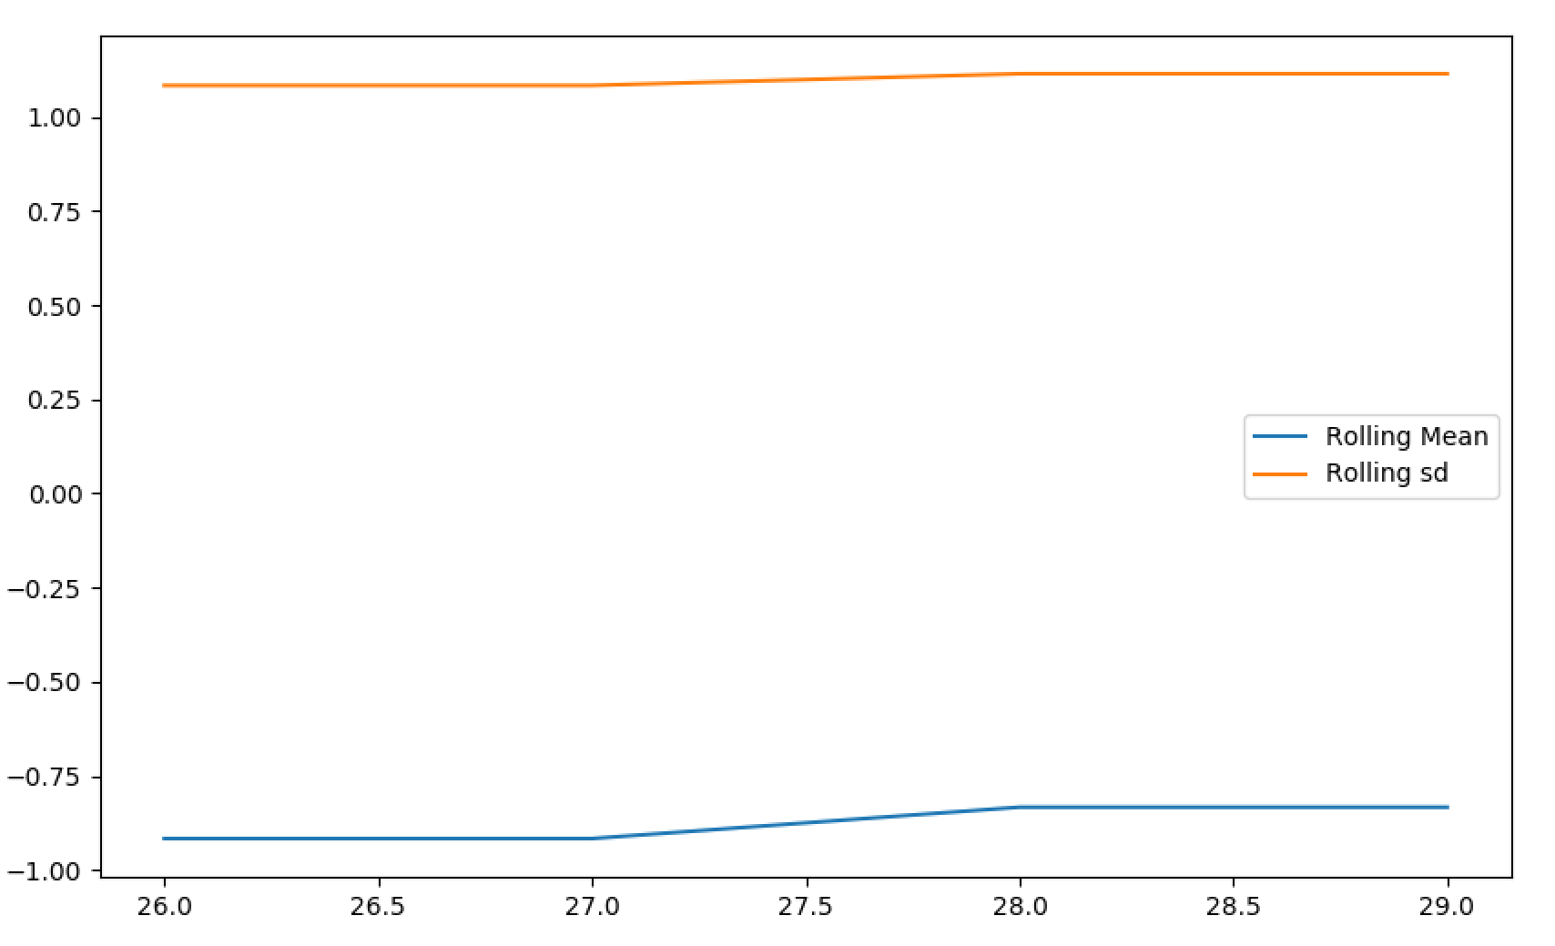

Rolling means (or moving averages) are generally used to smooth out short-term fluctuations in time series data and highlight long-term trends.

TODO: 加上Rolling std的介绍。

* 1. Decomposition into Trend, seasonality and residuals

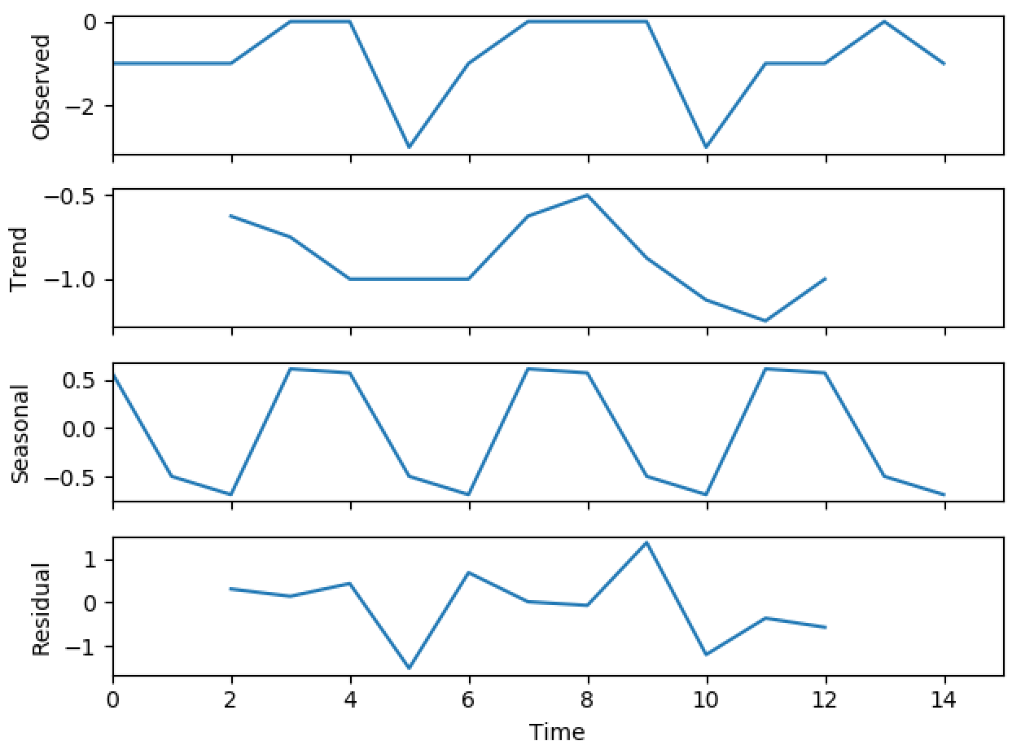

TODO: 加上注释。

1. Feature(variable) relationship analysis

*If it’s a classification problem, need to analysis the relationship within different* ***class****.*

* 1. Basic

TODO: 注释。

* + 1. Numeric (Linear)

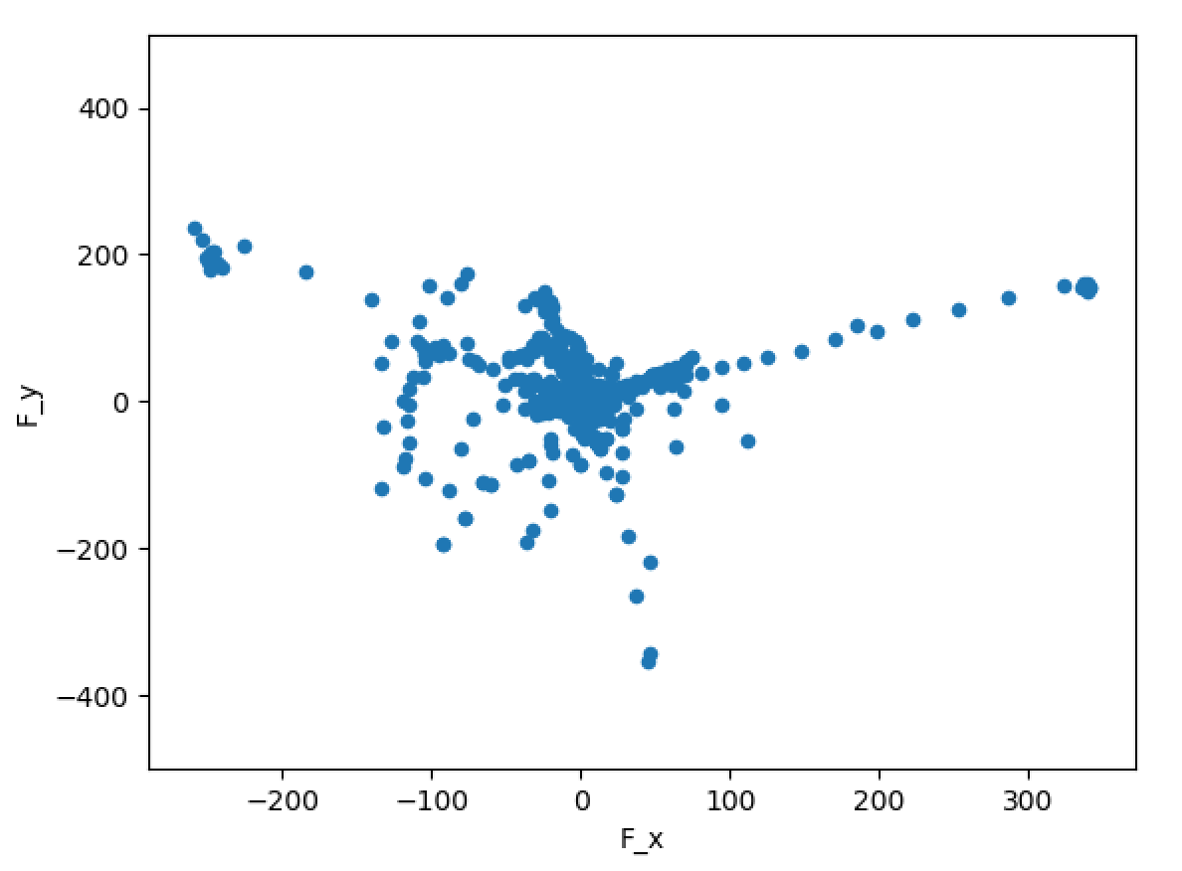

* + 1. Category (Box)
  1. Correlation matrix

|  |
| --- |
| F_x F_y F_z T_x T_y T_z  F_x 1.000000 -0.734562 0.220785 0.734160 0.599033 0.084029  F_y -0.734562 1.000000 -0.011925 -0.972381 -0.669026 -0.607716  F_z 0.220785 -0.011925 1.000000 -0.094079 0.304441 -0.120590  T_x 0.734160 -0.972381 -0.094079 1.000000 0.714075 0.522662  T_y 0.599033 -0.669026 0.304441 0.714075 1.000000 0.195646  T_z 0.084029 -0.607716 -0.120590 0.522662 0.195646 1.000000 |

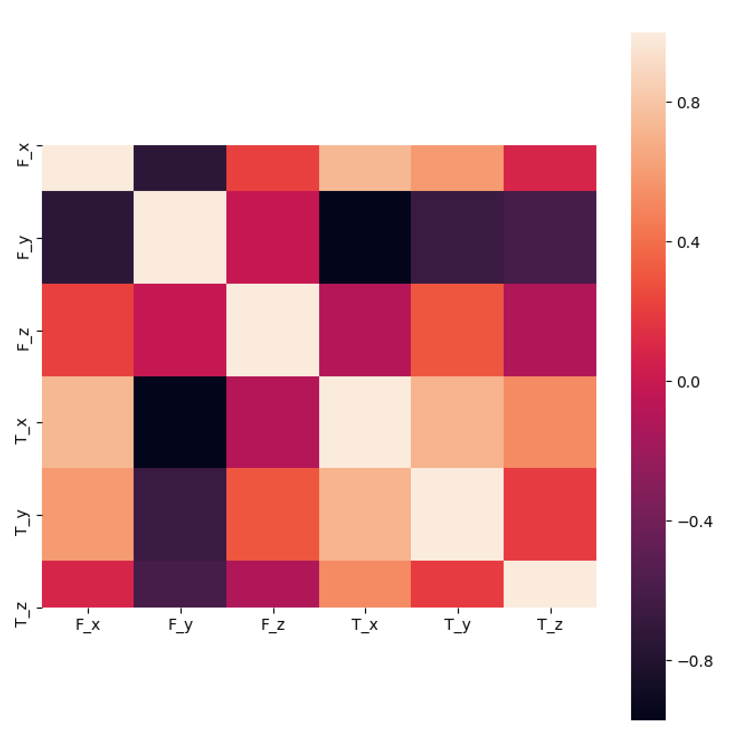

TODO: 注释。